ASSIGNMENT 4:
Module 5: Files, Exceptions, and Errors in Python

Task 1: Read a File and Handle Errors
Problem Statement: Write a Python program that:
1. Opens and reads a text file named sample.txt.
2. Prints its content line by line.
3. Handles errors gracefully if the file does not exist.

Expected Output:
If the file exists:
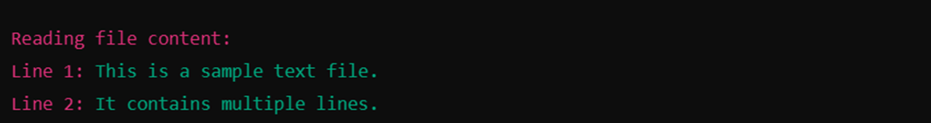
If the file does not exist:

Task 2: Write and Append Data to a File

Problem Statement: Write a Python program that:
1. Takes user input and writes it to a file named output.txt.
2. Appends additional data to the same file.
3. Reads and displays the final content of the file.
Expected Output:
For example, if the user enters 25, the output should be:
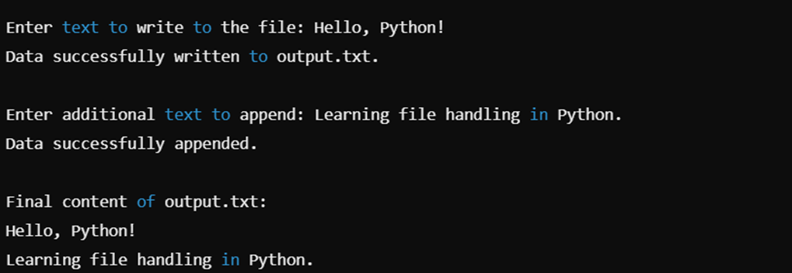

Submission Instructions:
- Create a GitHub repository and upload your Python scripts (.py files).
- Ensure the repository includes a README.md file that describes the functionality of your programs.
- Add both Task 1 and Task 2 scripts in the same repository.
- Submit the link to your GitHub repository once uploaded.

Reference:
Follow the Python course - Module 4: Functions & Modules in Python for additional guidelines and examples.

Note:
Please test your project thoroughly and check all the validations and error handling prior to ensure it works as expected before submission.
You can always connect to the mentor using the chat support option for any doubts or queries!

